**Module-2: GIT Assignment – 3**

● Create a git working directory, with the following branches

○ Develop

○ F1

○ f2

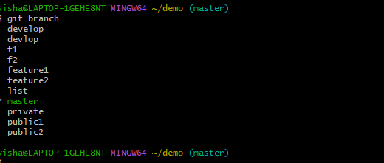

● In the master branch, commit main.txt file

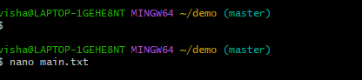

● Put develop.txt in develop branch, f1.txt and f2.txt in f1 and f2 respectively.

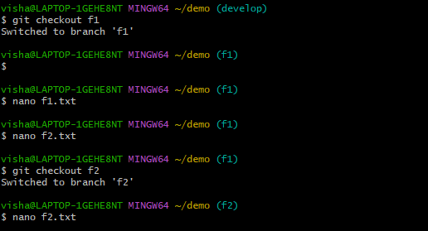

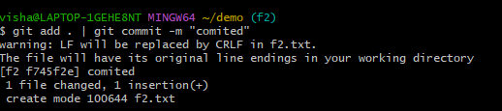

● Push all these branches to github.

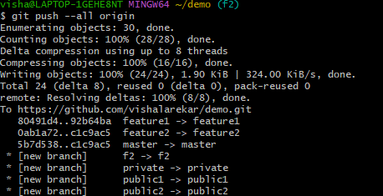

● On local delete f2 branch.

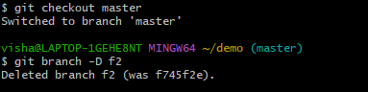

● Delete the same branch on github as well.

